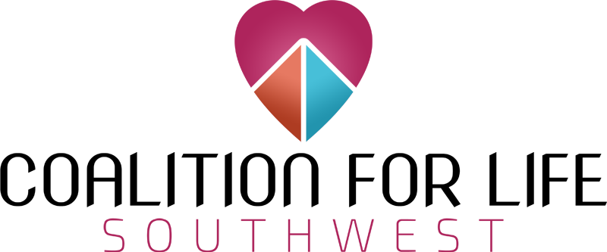
[DATE OF EVENT]
I, [NAME OF REGISTRANT], testify to the following agreements during my involvement with the Southwest Coalition for Life and the [NAME OF EVENT]:
- I will only pursue peaceful solutions to the violence of abortion when volunteering with the Southwest Coalition for Life and all of its programs.
- I will show compassion and reflect Christ’s love to all "Hill Top Women's Reproductive Clinic" and “Planned Parenthood” employees, volunteers, customers, and passersby;
- I understand that acting in a violent, harmful, or threatening manner immediately and completely disassociates me from the Southwest Coalition for Life and all of its programs;
- I am in no way associated with Hill Top, Planned Parenthood, their affiliates, nor any abortion provider.
- I will not harass, intimidate, nor argue with fellow volunteers or pro-lifers on the sidewalk.
While standing in the public right-of-way in front of Planned Parenthood, Hill Top, or Women’s Reproductive Services:
- I will not obstruct the driveways or sidewalk;
- I will not litter;
- I will closely attend to any children I bring to the prayer vigil;
- I will not threaten, physically contact, or verbally abuse any employees, volunteers, or customers of Hill Top or Planned Parenthood;
- I will not damage nor trespass on private property;
- I will cooperate with local authorities.
- If I am a minor, I will participate only in the presence of or with the written permission of a parent or guardian.
Signed,
[NAME OF REGISTRANT], DOB [DATE OF BIRTH]
[ADDRESS OF REGISTRANT], [CITY OF REGISTRANT], [ZIP CODE OF REGISTRANT]
[REGISTRANT PHONE NUMBER]

